**Part A: Contact Manager**

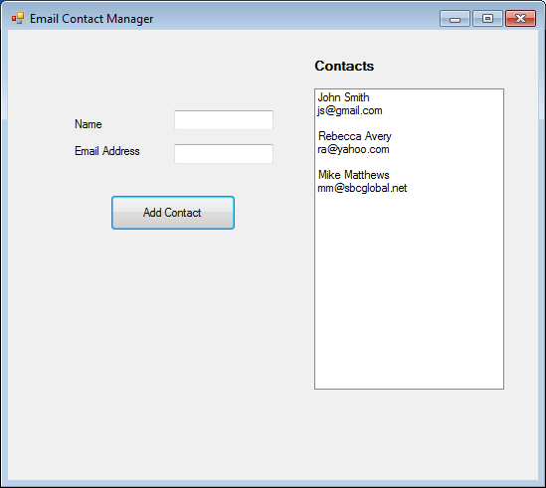

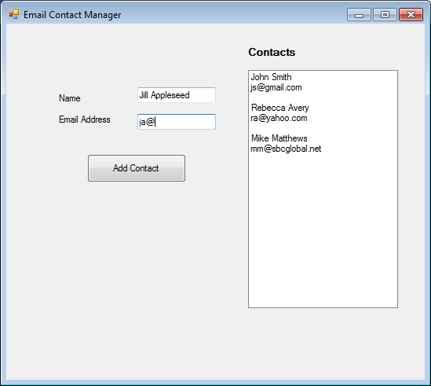

// ---------------------------------------------------------------

// Programming Assignment: LAB7A

// Developer: Anthony Meunier

// Date Written: 8/23/2014

// Purpose: Contact Manager

// ---------------------------------------------------------------

using System;

using System.Collections.Generic;

using System.ComponentModel;

using System.Data;

using System.Drawing;

using System.Linq;

using System.Text;

using System.Threading.Tasks;

using System.Windows.Forms;

using System.IO;

namespace CIS170B_Lab7A_Meunier_A

{

public partial class Form1 : Form

{

public StreamWriter outFile;

public StreamReader inFile;

public Form1()

{

InitializeComponent();

}

private void listBox1_SelectedIndexChanged(object sender, EventArgs e)

{

}

private void btnAddContact_Click(object sender, EventArgs e)

{

try

{

outFile = new StreamWriter("cis170Lab7.txt", true);

outFile.WriteLine(txtName.Text);

outFile.WriteLine(txtEmail.Text);

outFile.WriteLine();

outFile.Close();

txtEmail.Text = "";

txtName.Text = "";

}

catch (System.IO.IOException exc)

{

MessageBox.Show(exc.Message);

}

//display data from file

lstContacts.Items.Clear();

string inval;

try

{

inFile = new StreamReader("cis170Lab7.txt");

while ((inval = inFile.ReadLine()) != null)

{

lstContacts.Items.Add(inval);

}

inFile.Close();

}

catch (System.IO.IOException exc)

{

MessageBox.Show(exc.Message);

}

}

private void Form1_FormClosing(object sender, FormClosingEventArgs e)

{

outFile.Close();

inFile.Close();

}

}

}